INTERNSHIP REPORT

A report submitted in partial fulfillment of the requirements for the Award of Degree of

BACHELOR OF TECHNOLOGY
In

COMPUTER SCIENCE AND ENGINEERING & AIML
By

STUDENT NAME – TANISHK MALVIYA
ENROLLMENT NO- 0192AL221117

Under Supervision of Mr. Jagdish Pathak
(Duration: 21 June, 2025 to 21 July, 2025)



DEPARTMENT OF COMPUTER SCIENCE & ENGINEERING AIML
TECHNOCRATS INSTITUTE OF TECHNOLOGY & SCIENCE BHOPAL
SESSION: 2025-26

TECHNOCRATS INSTITUTE OF TECHNOLOGY & SCIENCE BHOPAL
DEPARTMENT OF COMPUTER SCIENCE & AIML

CERTIFICATE

This is to certify that the “Manual Software Testing Internship Report” submitted by Tanishk Malviya 192AL221117 is work done by her and submitted during 2025 – 2026 academic year, in partial fulfillment of the requirements for the award of the degree of BACHELOR OF TECHNOLOGY in COMPUTER SCIENCE AND ENGINEERING-AIML, at Ramraj Technology Solutions Private Limited.

Department Internship Coordinator
Prof. Sakshi Tiwari
Assistant professor
Prof. Rakesh Kumar Tiwari
Head of the Department (CSE & AIML)

CERTIFICATE PASTE HERE

ACKNOWLEDGEMENT

First I would like to thank Mr. Jagdish Pathak of Ramraj Technology Solutions Private Limited, Bhopal for giving me the opportunity to do an internship within the organization.

I also would like all the people that worked along with me Ramraj Technology Solutions Private Limited, Bhopal with their patience and openness they created an enjoyable working environment.

It is indeed with a great sense of pleasure and immense sense of gratitude that I acknowledge the help of these individuals.
I am highly indebted to Director Prof. (Dr.) Shashi Kumar Jain for the facilities provided to accomplish this internship.
I would like to thank my Head of the Department Prof. Rakesh Kumar Tiwari for his constructive criticism throughout my internship.
I would like to thank Prof. Sakshi Tiwari internship coordinator Department of CSE & AIML for their support and advices to get and complete internship in above said organization.

I am extremely great full to my department staff members and friends who helped me in successful completion of this internship.

Student name – Tanishk Malviya
Enrollment number – 0192AL221117

About Ramraj Technology Solutions Private Limited (RTSPL)

Ramraj Technology Solutions Private Limited (RTSPL) is an IT solutions and consulting company founded in 2009 by engineering and management graduates from top institutions like IITs, IIMs, and Stanford University. Headquartered in Bhopal, Madhya Pradesh, RTSPL has a fully owned US subsidiary, Ramraj Tech Inc., in Palo Alto, California, established in 2017.

Services:
- IT Services: Customized IT solutions for governments, enterprises, and startups
- Business Consulting: Expert advice for businesses looking to improve operations and strategy
- Application Development: Full-stack application development services
- IT Infrastructure Deployment and Support: Comprehensive IT infrastructure solutions
- Digital Transformation: Helping businesses adapt to digital technologies
- Cyber Security: Protecting businesses from cyber threats
- Analytics and Data Sciences: Data analysis and interpretation services
- HR Recruitment: Recruitment services for HR professionals

Industries:
- Government
- Manufacturing
- Service Industry
- Education
- Transportation and Supply Chain
- Banking and Financial Services
- Pharma, Life Sciences, and Healthcare

Key Highlights:
- Team of over 250 software professionals
- Clients across USA, Europe, Australia, Africa, and Middle East
- Planned delivery centers in Bangalore, Hyderabad, and Pune
- Authorized share capital of ₹1,000,000 and paid-up capital of ₹1,000,000

MANUAL SOFTWARE TESTING

INTRODUCTION
Software engineering is an engineering branch associated with development of software product using well-defined scientific principles, methods and procedures. The outcome of software engineering is an efficient and reliable software product.
Software project management has wider scope than software engineering process as it involves communication, pre and post delivery support etc.
This tutorial should provide you basic understanding of software product, software design and development process, software project management and design complexities etc. At the end of the tutorial you should be equipped with well understanding of software engineering concepts.
Software is more than just a program code. A program is an executable code, which serves some computational purpose. Software is considered to be collection of executable programming code, associated libraries and documentations. Software, when made for a specific requirement is called software product.
Engineering on the other hand, is all about developing products, using well-defined, scientific principles and methods.
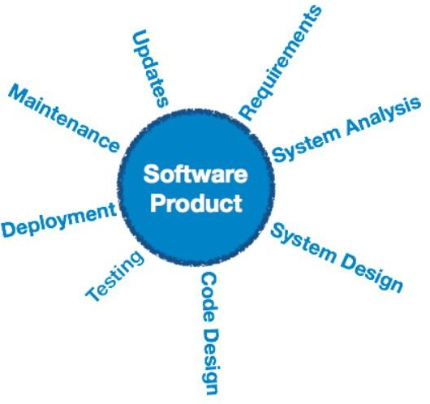
Software engineering is an engineering branch associated with development of software product using well-defined scientific principles, methods and procedures. The outcome of software engineering is an efficient and reliable software product.

Definitions

IEEE defines software engineering as:
- The application of a systematic, disciplined, quantifiable approach to the development, operation and maintenance of software; that is, the application of engineering to software.
- The study of approaches as in the above statement.

Fritz Bauer, a German computer scientist, defines software engineering as:
Software engineering is the establishment and use of sound engineering principles in order to obtain economically software that is reliable and work efficiently on real machines.

Software Evolution

The process of developing a software product using software engineering principles and methods is referred to as software evolution. This includes the initial development of software and its maintenance and updates, till desired software product is developed, which satisfies the expected requirements.
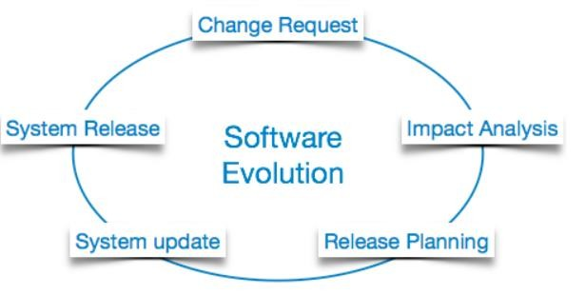
Evolution starts from the requirement gathering process. After which developers create a prototype of the intended software and show it to the users to get their feedback at the early stage of software product development. The users suggest changes, on which several consecutive updates and maintenance keep on changing too. This process changes to the original software, till the desired software is accomplished.
Even after the user has desired software in hand, the advancing technology and the changing requirements force the software product to change accordingly. Re-creating software from scratch and to go one-on-one with requirement is not feasible. The only feasible and economical solution is to update the existing software so that it matches the latest requirements.

Software Paradigms
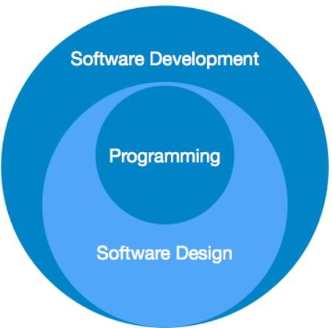
Programming paradigm is a subset of Software design paradigm which is further a subset of Software development paradigm.

Software Development Paradigm
This Paradigm is known as software engineering paradigms where all the engineering concepts pertaining to the development of software are applied. It includes various researches and requirement gathering which helps the software product to build. It consists of –

- Requirement gathering
- Software design
- Programming

Software Design Paradigm
This paradigm is a part of Software Development and includes –

- Design
- Maintenance
- Programming

Programming Paradigm
This paradigm is related closely to programming aspect of software development. This includes –

- Coding
- Testing
- Integration

Need of Software Engineering

The need of software engineering arises because of higher rate of change in user requirements and environment on which the software is working.

- Large software - It is easier to build a wall than to a house or building, likewise, as the size of software become large engineering has to step to give it a scientific process.
- Scalability- If the software process were not based on scientific and engineering concepts, it would be easier to re-create new software than to scale an existing one.
- Cost- As hardware industry has shown its skills and huge manufacturing has lower down the price of computer and electronic hardware. But the cost of software remains high if proper process is not adapted.
- Dynamic Nature- The always growing and adapting nature of software hugely depends upon the environment in which user works. If the nature of software is always changing, new enhancements need to be done in the existing one. This is where software engineering plays a good role.
- Quality Management- Better process of software development provides better and quality software product.

Characteristics of good software

A software product can be judged by what it offers and how well it can be used. This software must satisfy on the following grounds:

- Operational
- Transitional
- Maintenance
Well-engineered and crafted software is expected to have the following characteristics:

Operational
This tells us how well software works in operations. It can be measured on:

- Budget
- Usability
- Efficiency
- Correctness
- Functionality
- Dependability
- Security
- Safety

Transitional
This aspect is important when the software is moved from one platform to another:

- Portability
- Interoperability
- Reusability
- Adaptability

Maintenance
This aspect briefs about how well software has the capabilities to maintain itself in the ever-changing environment:

- Modularity
- Maintainability
- Flexibility
- Scalability
In short, Software engineering is a branch of computer science, which uses well-defined engineering concepts required to produce efficient, durable, scalable, in-budget and on- time software products.
Software Development Life Cycle, SDLC for short, is a well-defined, structured sequence of stages in software engineering to develop the intended software product. SDLC is a process that consists of a series of planned activities to develop or alter the Software Products.
Software Development Life Cycle (SDLC) is a process used by the software industry to design, develop and test high quality softwares. The SDLC aims to produce a high-quality

Why to Learn Software Testing?

In the IT industry, large companies have a team with responsibilities to evaluate the developed software in context of the given requirements. Moreover, developers also conduct testing which is called Unit Testing. In most cases, the following professionals are involved in testing a system within their respective capacities −

  - Software Tester
  - Software Developer
  - Project Lead/Manager
  - End User
Different companies have different designations for people who test the software on the basis of their experience and knowledge such as Software Tester, Software Quality Assurance Engineer, QA Analyst, etc.

Applications of Software Testing

  - Cost Effective Development - Early testing saves both time and cost in many aspects, however reducing the cost without testing may result in improper design of a software application rendering the product useless.
  - Product Improvement - During the SDLC phases, testing is never a time-consuming process. However diagnosing and fixing the errors identified during proper testing is a time-consuming but productive activity.
  - Test Automation - Test Automation reduces the testing time, but it is not possible to start test automation at any time during software development. Test automaton should be started when the software has been manually tested and is stable to some extent. Moreover, test automation can never be used if requirements keep changing.
  - Quality Check - Software testing helps in determining following set of properties of any software such as
    - Functionality
    - Reliability
    - Usability
    - Efficiency
    - Maintainability
    - Portability

What is Testing?

Testing is the process of evaluating a system or its component(s) with the intent to find whether it satisfies the specified requirements or not. In simple words, testing is executing a system in order to identify any gaps, errors, or missing requirements in contrary to the actual requirements.
According to ANSI/IEEE 1059 standard, Testing can be defined as - A process of analyzing a software item to detect the differences between existing and required conditions (that is defects/errors/bugs) and to evaluate the features of the software item.

Who does Testing?

It depends on the process and the associated stakeholders of the project(s). In the IT industry, large companies have a team with responsibilities to evaluate the developed software in context of the given requirements. Moreover, developers also conduct testing which is called Unit Testing. In most cases, the following professionals are involved in testing a system within their respective capacities −

  - Software Tester
  - Software Developer
  - Project Lead/Manager
  - End User
Different companies have different designations for people who test the software on the basis of their experience and knowledge such as Software Tester, Software Quality Assurance Engineer, QA Analyst, etc.
It is not possible to test the software at any time during its cycle. The next two sections state when testing should be started and when to end it during the SDLC.

When to Start Testing?

An early start to testing reduces the cost and time to rework and produce error-free software that is delivered to the client. However in Software Development Life Cycle (SDLC), testing can be started from the Requirements Gathering phase and continued till the deployment of the software.
It also depends on the development model that is being used. For example, in the Waterfall model, formal testing is conducted in the testing phase; but in the incremental model, testing is performed at the end of every increment/iteration and the whole application is tested at the end.

Testing is done in different forms at every phase of SDLC −
  - During the requirement gathering phase, the analysis and verification of requirements are also considered as testing.
  - Reviewing the design in the design phase with the intent to improve the design is also considered as testing.
  - Testing performed by a developer on completion of the code is also categorized as testing.

When to Stop Testing?
It is difficult to determine when to stop testing, as testing is a never-ending process and no one can claim that software is 100% tested. The following aspects are to be considered for stopping the testing process −
  - Testing Deadlines
  - Completion of test case execution
  - Completion of functional and code coverage to a certain point
  - Bug rate falls below a certain level and no high-priority bugs are identified
  - Management decision

Roles and Responsibilities of a Software Tester
Test lead/manager: A test lead is responsible for:
- Defining the testing activities for subordinates – testers or test engineers.
- All responsibilities of test planning.
- To check if the team has all the necessary resources to execute the testing activities.
- To check if testing is going hand in hand with the software development in all phases.
- Prepare the status report of testing activities.
- Required Interactions with customers.
- Updating project manager regularly about the progress of testing activities.

Test engineers/QA testers/QC testers are responsible for:
- To read all the documents and understand what needs to be tested.
- Based on the information procured in the above step decide how it is to be tested.
- Inform the test lead about what all resources will be required for software testing.
- Develop test cases and prioritize testing activities.
- Execute all the test case and report defects, define severity and priority for each defect.
- Carry out regression testing every time when changes are made to the code to fix defects.
Overview of Software Engineering Team

How a software application shapes up during the development process entirely depends on the how the software engineering team organizes work and implements various methodologies. For an application to develop properly, it is important that all processes incorporated during the software development are stable and sustainable. Many times developers come under pressure as the delivery date approaches closer this often affects the quality of the software. Rushing through the processes to finish the project on time will only produce a software application which has no or minimal use for the customers. Hence, work organization and planning is important and sticking to the plan is very important. The project manager should ensure that there are no obstacles in the development process and if at all there is an issue it must be resolved with immediate attention.

Overview of Software Testing Team
How soon and how well you can achieve your testing goals depends solely on the capabilities of the testing team. Within the testing team itself it is important to have the correct blend of testers who can efficiently work together to achieve the common testing goals. While forming a team for testing, it is important to ensure that the members of the team jointly have a combination of all the relevant domain knowledge that is required to test the software under development.
It is very important to ensure that the software testing team has a proper structure. The hierarchy and roles should be clearly defined and responsibilities too should be well defined and properly distributed amongst the team members. When the team is well organized the

work can be handled well. If every team member knows what duties he or she has to perform then they will be able to finish their duties as required well within the time limit. It is important to keep track of the testers’ performance. It is very important to check what kind of defects the tester is able to uncover and what kind of detects he tends to miss. This will give you a fair idea about how serious your team is about the work.
All the team members should work together to prepare a document that clearly defines the roles and responsibilities of all the team members. Once the document is prepared the role of each member should be communicated clearly to everyone. Once the team members are clear about who is going to handle which area of the project, then in case of any issue it will be easy to determine who needs to be contacted.
Each member of the team should be provided with the necessary documents that provide information on how the task would be organized, what approach will be followed, how things are scheduled, how many hours have been allocated to each member and all details related to applicable standards and quality processes.

Software Tester Role
A Software tester (software test engineer) should be capable of designing test suites and should have the ability to understand usability issues. Such a tester is expected to have sound knowledge of software test design and test execution methodologies. It is very important for a software tester to have great communication skills so that he can interact with the development team efficiently. The roles and responsibilities for a usability software tester are as follows:
- A Software Tester is responsible for designing testing scenarios for usability testing.
- He is responsible for conducting the testing, thereafter analyze the results and then submit his observations to the development team.
- He may have to interact with the clients to better understand the product requirements or in case the design requires any kind of modifications.
- Software Testers are often responsible for creating test-product documentation and also has to participate in testing related walk through.
A software tester has different sets of roles and responsibilities. He should have in depth knowledge about software testing. He should have a good understanding about the system which means technical (GUI or non-GUI human interactions) as well as functional product aspects. In order to create test cases it is important that the software tester is aware of various testing techniques and which approach is best for a particular system. He should know what are various phases of software testing and how testing should be carried out in each phase. The responsibilities of the software tester include:
- Creation of test designs, test processes, test cases and test data.
- Carry out testing as per the defined procedures.
- Participate in walkthroughs of testing procedures.
- Prepare all reports related to software testing carried out.
- Ensure that all tested related work is carried out as per the defined standards and procedures.

Software Test Manager Role

Managing or leading a test team is not an easy job. The company expects the test manager to know testing methodologies in detail. A test manager has to take very important decisions regarding the testing environment that is required, how information flow would be managed and how testing procedure would go hand in hand with development. He should have sound knowledge about both manual as well as automated testing so that he can decide how both the methodologies can be put together to test the software. A test
manager should have sound knowledge about the business area and the client’s requirement, based on that he should be able to design a test strategy, test goal and objectives. He should be good at project planning, task and people coordination, and he should be familiar with various types of testing tools. Many people get confused between the roles and responsibilities of a test manager and test lead.For a clarification, a test lead is supposed to have a rich technical experience which includes, programming, handling database technologies and various operating systems, whereas he may not be as strong as Software Test Manager regarding test project management and coordination. The responsibilities of the test manager are as follows:
- Since the test manager represents the team he is responsible for all interdepartmental meetings.
- Interaction with the customers whenever required.
- A test manager is responsible for recruiting software testing staff. He has to supervise all testing activities carried out by the team and identify team members who require more training.
- Schedule testing activities, create budget for testing and prepare test effort estimations.
- Selection of right test tools after interacting with the vendors. Integration of testing and development activities.
- Carry out continuous test process improvement with the help of metrics.
- Check the quality of requirements, how well they are defined.
- Trace test procedures with the help of test traceability matrix.

Software Test Automator Role
Software test automator or an automated test engineer should have very good understanding of what he needs to test- GUI designs, load or stress testing. He should be proficient in automation of software testing, and he should be able to design test suites accordingly. A software test automator should be comfortable using various kinds of automation tools and should be capable of upgrading their skills with changing trends. He should also have programming skills so that he is able to write test scripts without any issues. The responsibilities of a tester at this position are as follows:
- He should be able to understand the requirement and design test procedures and test cases for automated software testing.
- Design automated test scripts that are reusable.
- Ensure that all automated testing related activities are carried out as per the standards defined by the company.

Interactions between Software Test Team And Business Teams
If at all a customer has any issues related to testing activities and operational matters of the project then it is the software testing manager who is responsible for communicating the details to the client regarding how things are being managed. The software testing manager

not only answers the queries of the customers but also ensures that the project is completed on time as per the requirement of the customer.
Interactions between Software Test Team And Development Teams
In order to produce good software applications, it is important that software testing and software development teams work together with good understanding. For this it is
important that the testers and developers are comfortable with each other’s role and understand well that they have a common goal and it is wise to listen each other. A good communication skill is very important both for testers and developers.
Before getting started with testing work it is important to discuss the basic guidelines and expectations so that there is no confusion in later stages. Criticism should be taken in a positive sense. It is important to understand that developers and testers have a common goal of producing high quality software. A tester is not discovering bugs to show someone down, the idea is to learn from mistakes and avoid repeating them in future. A culture of constructive criticism can be of great help.
Interactions between Software Test Team And Release Management Teams
The release management teams are responsible for moving the software from development into production. This team is responsible for planning the releases for hardware, software and testing. It is also responsible for development of software development procedures and for coordinating interactions and training of releases. Software testing is considered to be a very important aspect of software engineering life cycle but it does not get over with development. Testing and verification is a very important part of release management exercise.
Interactions between Software Test Manager And Software Project Manager
The job of a software test manager is not an easy one. He has to recruit testing team and take responsibility for getting them trained. A software manager has to perform ongoing analysis of various testing processes and ensure that the testing team is carrying out all the processes correctly. This job is of great responsibility as the software testing manager is the one who selects, introduces and implement various tools for testing. A software test manager is responsible for finalizing templates for testing documents, test reports and other procedures.
Since a software tester manager has to deal with all the details of various testing activities, it is very important for him to be in constant touch with the project manager and provide necessary support in project planning and scheduling so that the project can be successfully completed in time within the specified financial budget limits.

Verification & Validation

These two terms are very confusing for most people, who use them interchangeably. The following table highlights the differences between verification and validation.

Sr.No. | Verification | Validation
1 | Verification addresses the concern: "Are you building it right?" | Validation addresses the concern: "Are you building the right thing?"
2 | Ensures that the software system meets all the functionality. | Ensures that the functionalities meet the intended behavior.

3 | Verification takes place first and includes the checking for documentation, code, etc. | Validation occurs after verification and mainly involves the checking of the overall product.
4 | Done by developers. | Done by testers.
5 | It has static activities, as it includes collecting reviews, walkthroughs, and inspections to verify a software. | It has dynamic activities, as it includes executing the software against the requirements.
6 | It is an objective process and no subjective decision should be needed to verify a software. | It is a subjective process and involves subjective decisions on how well a software works.

Software testing is a procedure of implementing software or the application to identify the defects or bugs. For testing an application or software, we need to follow some principles to make our product defects free, and that also helps the test engineers to test the software with their effort and time. Here, in this section, we are going to learn about the seven essential principles of software testing.

Let us see the seven different testing principles, one by one:

- Testing shows the presence of defects
- Exhaustive Testing is not possible
- Early Testing
- Defect Clustering
- Pesticide Paradox
- Testing is context-dependent
- Absence of errors fallacy

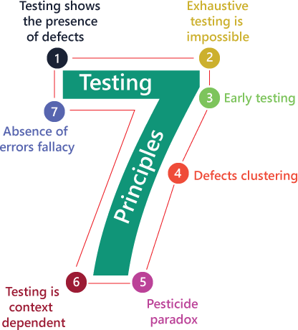

The test engineer will test the application to make sure that the application is bug or defects free. While doing testing, we can only identify that the application or software has any errors. The primary purpose of doing testing is to identify the numbers of unknown bugs with the help of various methods and testing techniques because the entire test should be traceable to the customer requirement, which means that to find any defects that might cause the product failure to meet the client's needs.
By doing testing on any application, we can decrease the number of bugs, which does not mean that the application is defect-free because sometimes the software seems to be bug- free while performing multiple types of testing on it. But at the time of deployment in the production server, if the end-user encounters those bugs which are not found in the testing process.

Exhaustive Testing is not possible

Sometimes it seems to be very hard to test all the modules and their features with effective and non- effective combinations of the inputs data throughout the actual testing process.

Hence, instead of performing the exhaustive testing as it takes boundless determinations and most of the hard work is unsuccessful. So we can complete this type of variations according to the importance of the modules because the product timelines will not permit us to perform such type of testing scenarios.

Early Testing

Here early testing means that all the testing activities should start in the early stages of the software development life cycle's requirement analysis stage to identify the defects because if we find the bugs at an early stage, it will be fixed in the initial stage itself, which may cost us very less as compared to those which are identified in the future phase of the testing process.

To perform testing, we will require the requirement specification documents; therefore, if the requirements are defined incorrectly, then it can be fixed directly rather than fixing them in another stage, which could be the development phase.

Defect clustering

The defect clustering defined that throughout the testing process, we can detect the numbers of bugs which are correlated to a small number of modules. We have various reasons for this, such as the modules could be complicated; the coding part may be complex, and so on.

These types of software or the application will follow the Pareto Principle, which states that we can identify that approx. Eighty percent of the complication is present in 20 percent of the modules. With the help of this, we can find the uncertain modules, but this method has its difficulties if the same tests are performing regularly, hence the same test will not able to identify the new defects.

Pesticide paradox

This principle defined that if we are executing the same set of test cases again and again over a particular time, then these kinds of the test will not be able to find the new bugs in the software or the application. To get over these pesticide paradoxes, it is very significant to review all the test cases frequently. And the new and different tests are necessary to be written for the implementation of multiple parts of the application or the software, which helps us to find more bugs.

Testing is context-dependent

Testing is a context-dependent principle states that we have multiple fields such as e- commerce websites, commercial websites, and so on are available in the market. There is a definite way to test the commercial site as well as the e-commerce websites because every application has its own needs, features, and functionality. To check this type of application, we will take the help of various kinds of testing, different technique, approaches, and multiple methods. Therefore, the testing depends on the context of the application.

Absence of errors fallacy

Once the application is completely tested and there are no bugs identified before the release, so we can say that the application is 99 percent bug-free. But there is the chance when the application is tested beside the incorrect requirements, identified the flaws, and fixed them on a given period would not help as testing is done on the wrong specification, which does not apply to the client's requirements. The absence of error fallacy means identifying and fixing the bugs would not help if the application is impractical and not able to accomplish the client's requirements and needs.
Software Testing Review process:

A software review is a process or meeting during which a software product is examined by a project personnel, users, computers, user representatives, or other interested parties for comment or approval."

It is very clear from the above definition that a software review is as essential as software testing. A software review has its own significance as it provides a better view on the developed software. It requires a team that can provide insights of the build software.

In the review, various things come to surface such as future casualties, technical content, quality, specifications of the software, etc. This deep overview of a software gives an idea that how will the software run and is shortcomings that are likely to occur in the near future. It also provides an idea that this software is even worth launching. Sometimes, the software has fewer benefits and greater number of disadvantages falling, in this condition the software is discarded or a better development of better software is proposed.

The value of the software is defined by the reviews. The qualified team looks over the software as per the guidelines provided to them. The specifications and standards are kept in mind while reviewing build software. It is a healthy form of discussion between the people who are in direct developers of the authors as well as the staff associated.

Types of Review in Software Testing
There are mainly Three Types of Reviews in a Software Testing.

Software Peer Reviews:
This type of review is conducted by the main author of the software, or it can be between the colleagues so that the evaluation can be done of the technical content or quality of the work. A discussion is always a solution for a software analysis. Aforementioned, it always provides a deeper insight of the software shortcomings and also its benefits. If the software shortcoming weigh higher than benefits, the software goes in testing mode again and it rectified as required.
Different types of Software Peer Reviews are there which are enumerated below:
  - Code Review: The source code of the software is examined here. The software is checked for the bugs and the bugs are removed from the code.
  - Pair programming: It is also a type of code review involving two people. The two people develop a code together at the same workstation.
  - Inspection: It is a formal type of review where a person has to go through a defined set of instructions in order to find defect/defects. There can be a number of reviewers involved in this type of reviewing.

  - Walkthrough: This is a process where the authors of the software as well as other associates are gathered at one place and they discuss about the software defects. Questions are made, comments are given, answers are given to all the queries people have regarding the software. With all the members' satisfaction, conclusions are made.
  - Technical review: This is the team of qualified personnel examines the suitability of the software product for its intended discrepancies from the specification and standards point of view.

Software Management Reviews:
The management representatives are responsible for this type of review. The status of the work is evaluated and the decision by the activities of the software. This review is very important in making a decision regarding software.

Software Audit Reviews:
These are conducted by the personnel outside of the software project. They evaluate the software with specifications, standards, and other criteria.
All the reviews are important to make software run successfully. Formal code reviews require a huge amount of investment of the time and the preparation of the review. Internal disputes also may carry leverage on these reviews. It is a time taking process and it may not be that accurate.
There are certain guidelines that a person has to follow to perform a perfect review on build software.
  - Defect Prevention is the main goal of the software as well as look out for the functionality of the software.
  - Review of the requirement specifications should be done carefully so as to evaluate the software as per required.
  - The list should be clarified.
  - Correctness, portability, security and maintainability should be checked in build software.

TESTING TECHNIQUES
Type of Software testing

We have various types of testing available in the market, which are used to test the application or the software.

With the help of below image, we can easily understand the type of software testing:

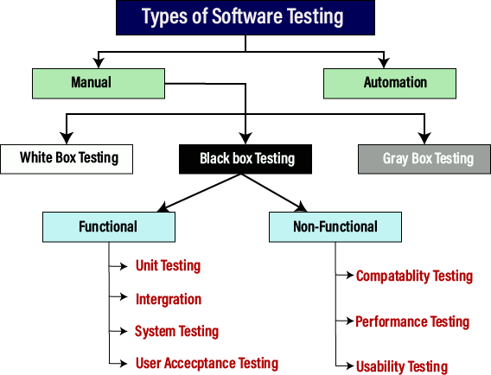

Manual testing

The process of checking the functionality of an application as per the customer needs without taking any help of automation tools is known as manual testing. While performing the manual testing on any application, we do not need any specific knowledge of any testing tool, rather than have a proper understanding of the product so we can easily prepare the test document.

Manual testing can be further divided into three types of testing, which are as follows:

White box testing
- Black box testing
- Gray box testing

Automation testing

Automation testing is a process of converting any manual test cases into the test scripts with the help of automation tools, or any programming language is known as automation testing. With the help of automation testing, we can enhance the speed of our test execution because here, we do not require any human efforts. We need to write a test script and execute those scripts.

White Box Testing

The box testing approach of software testing consists of black box testing and white box testing. We are discussing here white box testing which also known as glass box is testing, structural testing, clear box testing, open box testing and transparent box testing. It tests internal coding and infrastructure of a software focus on checking of predefined inputs against expected and desired outputs. It is based on inner workings of an application and revolves around internal structure testing. In this type of testing programming skills are required to design test cases. The primary goal of white box testing is to focus on the flow of inputs and outputs through the software and strengthening the security of the software.

The term 'white box' is used because of the internal perspective of the system. The clear box or white box or transparent box name denote the ability to see through the software's outer shell into its inner workings.

Developers do white box testing. In this, the developer will test every line of the code of the program. The developers perform the White-box testing and then send the application or the software to the testing team, where they will perform the black box testing and verify the application along with the requirements and identify the bugs and sends it to the developer.

The developer fixes the bugs and does one round of white box testing and sends it to the testing team. Here, fixing the bugs implies that the bug is deleted, and the particular feature is working fine on the application.

Here, the test engineers will not include in fixing the defects for the following reasons:

- Fixing the bug might interrupt the other features. Therefore, the test engineer should always find the bugs, and developers should still be doing the bug fixes.
- If the test engineers spend most of the time fixing the defects, then they may be unable to find the other bugs in the application.
The white box testing contains various tests, which are as follows:

- Path testing
- Loop testing
- Condition testing

- Testing based on the memory perspective
- Test performance of the program

Path testing

In the path testing, we will write the flow graphs and test all independent paths. Here writing the flow graph implies that flow graphs are representing the flow of the program and also show how every program is added with one another as we can see in the below image:

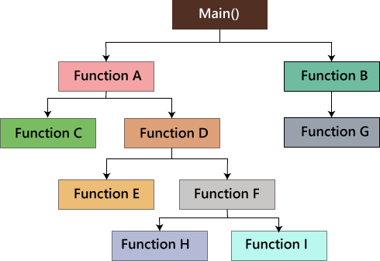

And test all the independent paths implies that suppose a path from main() to function G, first set the parameters and test if the program is correct in that particular path, and in the same way test all other paths and fix the bugs.

Loop testing

In the loop testing, we will test the loops such as while, for, and do-while, etc. and also check for ending condition if working correctly and if the size of the conditions is enough.

For example: we have one program where the developers have given about 50,000 loops.

For example: we have one program where the developers have given about 50,000 loops.

1. {
2. while(50,000)
3. ……

4. ……
5. }

We cannot test this program manually for all the 50,000 loops cycle. So we write a small program that helps for all 50,000 cycles, as we can see in the below program, that test P is written in the similar language as the source code program, and this is known as a Unit test. And it is written by the developers only.

1. Test P 2. {
3. ……
4. …… }

As we can see in the below image that, we have various requirements such as 1, 2, 3, 4. And then, the developer writes the programs such as program 1,2,3,4 for the parallel conditions. Here the application contains the 100s line of codes.

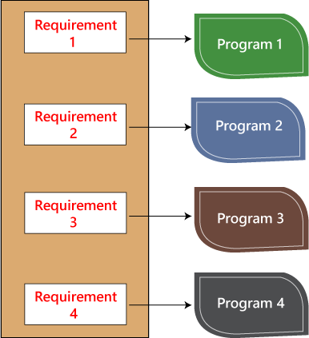

The developer will do the white box testing, and they will test all the five programs line by line of code to find the bug. If they found any bug in any of the programs, they will correct it. And they again have to test the system then this process contains lots of time and effort and slows down the product release time.

Now, suppose we have another case, where the clients want to modify the requirements, then the developer will do the required changes and test all four program again, which take lots of time and efforts.

These issues can be resolved in the following ways:

In this, we will write test for a similar program where the developer writes these test code in the related language as the source code. Then they execute these test code, which is also known as unit test programs. These test programs linked to the main program and implemented as programs.
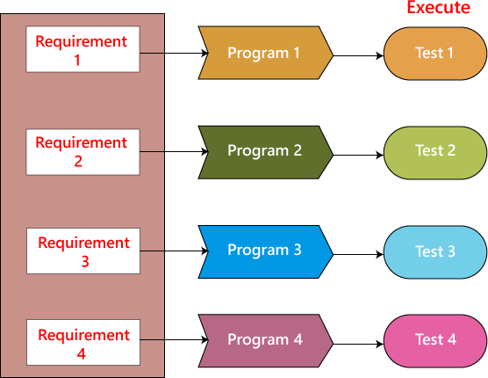

Therefore, if there is any requirement of modification or bug in the code, then the developer makes the adjustment both in the main program and the test program and then executes the test program.

Condition testing

In this, we will test all logical conditions for both true and false values; that is, we will verify for both if and else condition.

For example:

1. if(condition) - true

2. {
3. …..
4. ……
5. ……
6. }
7. else - false 8. {
9. …..
10. ……
11. ……
12. }

The above program will work fine for both the conditions, which means that if the condition is accurate, and then else should be false and conversely.

Testing based on the memory (size) perspective

The size of the code is increasing for the following reasons:

- The reuse of code is not there: let us take one example, where we have four programs of the same application, and the first ten lines of the program are similar. We can write these ten lines as a discrete function, and it should be accessible by the above four programs as well. And also, if any bug is there, we can modify the line of code in the function rather than the entire code.
- The developers use the logic that might be modified. If one programmer writes code and the file size is up to 250kb, then another programmer could write a similar code using the different logic, and the file size is up to 100kb.
- The developer declares so many functions and variables that might never be used in any portion of the code. Therefore, the size of the program will increase.

For example,

- Int a=15;
- Int b=20;
- String S= "Welcome"; 4. ….
5. …..
6. …..
7. ….

8. …..
- Int p=b;
- Create user()
11. { 12. …… 13. ……
- 200's line of code
15. }

In the above code, we can see that the integer a has never been called anywhere in the program, and also the function Create user has never been called anywhere in the code. Therefore, it leads us to memory consumption.

We cannot remember this type of mistake manually by verifying the code because of the large code. So, we have a built-in tool, which helps us to test the needless variables and functions. And, here we have the tool called Rational purify.

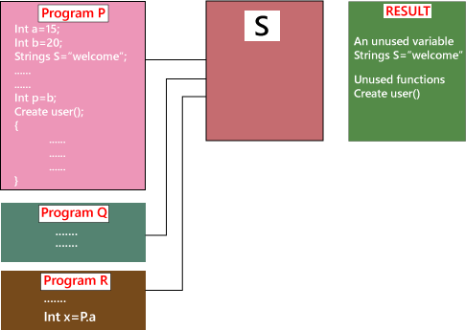

Suppose we have three programs such as Program P, Q, and R, which provides the input to
S. And S goes into the programs and verifies the unused variables and then gives the outcome. After that, the developers will click on several results and call or remove the unnecessary function and the variables.

This tool is only used for the C programming language and C++ programming language; for another language, we have other related tools available in the market.

  - The developer does not use the available in-built functions; instead they write the full features using their logic. Therefore, it leads us to waste of time and also postpone the product releases.

Test the performance (Speed, response time) of the program The application could be slow for the following reasons:
  - When logic is used.
  - For the conditional cases, we will use or & and adequately.
  - Switch case, which means we cannot use nested if, instead of using a switch case.

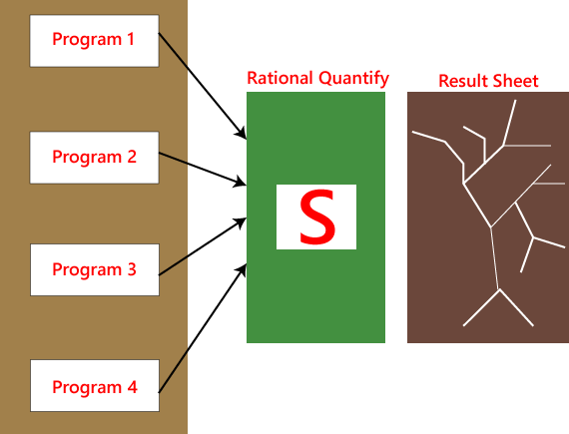

As we know that the developer is performing white box testing, they understand that the code is running slow, or the performance of the program is also getting deliberate. And the developer cannot go manually over the program and verify which line of the code is slowing the program.

To recover with this condition, we have a tool called Rational Quantify, which resolves these kinds of issues automatically. Once the entire code is ready, the rational quantify tool

will go through the code and execute it. And we can see the outcome in the result sheet in the form of thick and thin lines.

Here, the thick line specifies which section of code is time-consuming. When we double-click on the thick line, the tool will take us to that line or piece of code automatically, which is also displayed in a different color. We can change that code and again and use this tool.
When the order of lines is all thin, we know that the presentation of the program has enhanced. And the developers will perform the white box testing automatically because it saves time rather than performing manually.

Test cases for white box testing are derived from the design phase of the software development lifecycle. Data flow testing, control flow testing, path testing, branch testing, statement and decision coverage all these techniques used by white box testing as a guideline to create an error-free software.
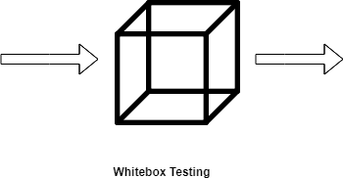

White box testing follows some working steps to make testing manageable and easy to understand what the next task to do. There are some basic steps to perform white box testing.

Generic steps of white box testing

  - Design all test scenarios, test cases and prioritize them according to high priority number.
  - This step involves the study of code at runtime to examine the resource utilization, not accessed areas of the code, time taken by various methods and operations and so on.
  - In this step testing of internal subroutines takes place. Internal subroutines such as nonpublic methods, interfaces are able to handle all types of data appropriately or not.
  - This step focuses on testing of control statements like loops and conditional statements to check the efficiency and accuracy for different data inputs.

  - In the last step white box testing includes security testing to check all possible security loopholes by looking at how the code handles security.

Reasons for white box testing

  - It identifies internal security holes.
  - To check the way of input inside the code.
  - Check the functionality of conditional loops.
  - To test function, object, and statement at an individual level.

Advantages of White box testing

  - White box testing optimizes code so hidden errors can be identified.
  - Test cases of white box testing can be easily automated.
  - This testing is more thorough than other testing approaches as it covers all code paths.
  - It can be started in the SDLC phase even without GUI.

Disadvantages of White box testing

  - White box testing is too much time consuming when it comes to large-scale programming applications.
  - White box testing is much expensive and complex.
  - It can lead to production error because it is not detailed by the developers.
  - White box testing needs professional programmers who have a detailed knowledge and understanding of programming language and implementation.

Techniques Used in White Box Testing

Data Flow Testing | Data flow testing is a group of testing strategies that examines the control flow of programs in order to explore the sequence of variables according to the sequence of events.
Control Flow Testing | Control flow testing determines the execution order of statements or instructions of the program through a control structure. The control structure of a program is used to develop a test case for the program. In this technique, a particular part of a large program is selected by the

 | tester to set the testing path. Test cases represented by the control graph of the program.
Branch Testing | Branch coverage technique is used to cover all branches of the control flow graph. It covers all the possible outcomes (true and false) of each condition of decision point at least once.
Statement Testing | Statement coverage technique is used to design white box test cases. This technique involves execution of all statements of the source code at least once. It is used to calculate the total number of executed statements in the source code, out of total statements present in the source code.
Decision Testing | This technique reports true and false outcomes of Boolean expressions. Whenever there is a possibility of two or more outcomes from the statements like do while statement, if statement and case statement (Control flow statements), it is considered as decision point because there are two outcomes either true or false.

Static Testing

In this section, we are going to understand Static testing, which is used to check the application without executing the code. And we also learn about static Testing, why we use static Testing, how to perform it, a different technique for static Testing, advantages of static testing, and various Static Testing tools.

Introduction to Static Testing

Static testing is a verification process used to test the application without implementing the code of the application. And it is a cost-effective process.

To avoid the errors, we will execute Static testing in the initial stage of development because it is easier to identify the sources of errors, and it can fix easily.

In other words, we can say that Static testing can be done manually or with the help of tools to improve the quality of the application by finding the error at the early stage of development; that is also called the verification process.

We can do some of the following important activities while performing static testing:

Business requirement review
  - Design review

Code walkthroughs
  - The test documentation review
Note: Static testing is performed in the white box testing phase, where the developer checks every line of the code before giving it to the Test Engineer.

Static testing also helps us to identify those errors which may not be found by Dynamic Testing.

Why do we need to perform Static Testing?

We can perform static testing to fulfill the below aspects:

  - We can use static testing to improve the development productivity.
  - If we performed static testing on an application, we could find the detects in the earlier stages and easily fix them.
  - The usage of static testing will decrease the testing cost, development timescales, and time.

What are the different features we can test in Static Testing?

We can test the various testing activities in Static Testing, which are as follows:

  - BRD [Business Requirements Document]
  - Functional or system Requirements
  - Unit Use Cases
  - Prototype
  - Prototype Specification Document
  - Test Data
  - DB Fields Dictionary Spreadsheet
  - Documentation/Training Guides/ User Manual
  - Test Cases/Test Plan Strategy Document
  - Traceability Matrix Document
  - Performance Test Scripts/Automation When we performed Static Testing?

To perform static testing, we need to follow the below steps:

Step1: To review the design of the application entirely, we will perform the inspection process.

Step2: After that, we will use a checklist for each document under review to make sure that all reviews are covered completely.

We can also implement several activities while performing static testing, which are discussed in the following table:

Activities | Explanation
Architecture Review | o The architecture review activities contain all business- level processes such as network diagram, load balancing, server locations, protocol definitions, test equipment, database accessibility, etc.
Use Cases Requirements Validation | - It is used to authenticates all the end-user actions along with associated input and output.  - If the use case is more comprehensive and detailed, we can make more precise and inclusive test cases.
Functional Requirements Validation | - The functional requirement validation activity is used to make sure that all necessary elements identify correctly.  - And it also took care of the software, interface listings, network requirements, hardware, and database functionality.
Field Dictionary Validation | - In the field dictionary validation, we will test each field in the user interface specified to create field-level validation test cases.  - And we can check the fields for error messages,

 | minimum or maximum length, list values, etc.
Prototype/Screen Mockup Validation | o The prototype validation activity contains the authentication of requirements and uses cases.

Why we need Static Testing?

We required Static testing whenever we encounter the following situation while testing an application or the software:

Dynamic Testing is time-consuming
  - Flaws at earlier stages/identification of Bugs

Dynamic Testing is expensive
  - Increased size of the software Dynamic Testing is time-consuming
We need static testing to test the application as dynamic testing is time-taking process even though the dynamic testing identifies the bug and provides some information about the bug.

Flaws at earlier stages/identification of Bugs

When we are developing the software, we cannot completely rely on Dynamic testing as it finds the bugs or defects of the application/software at a later stage because it will take the programmer's plenty of time and effort to fix the bugs.

Dynamic Testing is expensive

We need to perform the static testing on the software product because dynamic testing is more expensive than static testing. Involving the test cases is expensive in dynamic testing as the test cases have been created in the initial stages.

And we also need to preserve the implementation and validation of the test case, which takes lots of time from the test engineers.

Increased size of the software

Whenever we test the software, it will increase the size of the software product, which we cannot handle because of the reduction in the productivity of code coverage.

That is why we require static testing to get free from the bugs or defects earlier in the software development life cycle.

Objectives of Static testing

The main objectives of performing static testing is as below:

  - Static testing will decrease the flaws in production.
  - Static testing will identify, anticipate and fix the bugs at the earliest possible time.
  - It is used to save both time and cost.
  - It is used to identify defects in the early stage of SDLC, where we can fix them easily.

Some useful points for Successful Static Testing Process

The following guidelines help us to perform a successful static testing process in Software testing.

  - We can train participants with examples.
  - The testing cost and time can decrease if we delete the major delays in test execution.
  - We can retain the process formal as per the project culture.
  - We can make emphasis only on things that matter.
  - As we know that a software walkthrough and review are usually merged into peer reviews; therefore, we can plan explicitly and track the review activities.
  - We can resolve the client's problems.

Static Testing Techniques

Static testing techniques offer a great way to enhance the quality and efficiency of software development. The Static testing technique can be done in two ways, which are as follows:

Review
  - Static Analysis

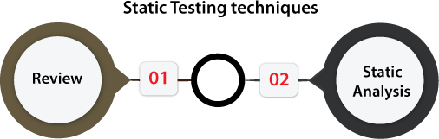

Review

In static testing, the review is a technique or a process implemented to find the possible bugs in the application. We can easily identify and eliminate faults and defects in the various supporting documents such as SRS [Software Requirements Specifications] in the review process.

In other words, we can say that a review in Static Testing is that where all the team members will understand about the project's progress.

In static testing, reviews can be divided into four different parts, which are as follows:

Informal reviews
  - Walkthroughs

Technical/peer review
  - Inspections
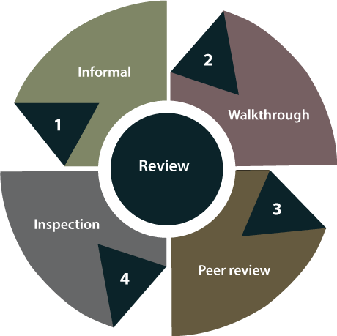

Let's understand them in detail one by one:

Informal reviews
In informal review, the document designer place the contents in front of viewers, and everyone gives their view; therefore, bugs are acknowledged in the early stage.

Walkthrough
Generally, the walkthrough review is used to performed by a skilled person or expert to verify the bugs. Therefore, there might not be problem in the development or testing phase.

Peer review
In Peer review, we can check one another's documents to find and resolve the bugs, which is generally done in a team.

Inspection
In review, the inspection is essentially verifying the document by the higher authority, for example, the verification of SRS [software requirement specifications] document.

Static Analysis

Another Static Testing technique is static analysis, which is used to contain the assessment of the code quality, which is established by developers.

We can use the different tools to perform the code's analysis and evaluation of the same.

In other words, we can say that developers' developed code is analyzed with some tools for structural bugs, which might cause the defects.

The static analysis will also help us to identify the below errors:

Dead code
  - Unused variables

Endless loops
  - Incorrect syntax

Variable with undefined value

In static testing, Static Analysis can be further classified into three parts, which are as discuss below:

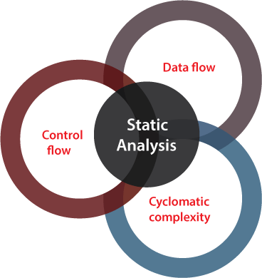

Data Flow: In static analysis, the data flow is connected to the stream processing.

Control Flow: Generally, the control flow is used to specify how the commands or instructions are implemented.

Cyclomatic Complexity: It is the measurement of the program's complexity, which is mostly linked to the number of independent paths in the control flow graph of the program.

Tools used for Static Testing

In static testing, we have several tools in the market, but here we are discussing the most commonly used tools, which are as follow:

CheckStyle
  - SourceMeter

Soot CheckStyle
It is a development tool that is used to help the developers write Java code, which follows a
coding standard. The CheckStyle tool automates the process of checking Java code.

It is a highly configured tool, which is made to support almost any coding standard. The Google Java Style, Sun code conventions are those configuration files, which is supported by CheckStyle.



Feature of CheckStyle

Following are the most common features of CheckStyle:

  - It can check various characteristics of our source code.
  - The CheckStyle code has the capability to verify the code layout and formatting issues.
  - It can also help to identify the method design problems, class design problems.

SourceMeter

It is an advanced tool for the specific static source code analysis of various programming languages such as C/C++, C#, Java, Python, and RPG projects.

With the SourceMeter tool's help, we can easily identify the vulnerable spots of a system under development from the source code.

The free version with partial functionality of SourceMeter can be accessible for all programming languages.

In SourceMeter, we can use the output of the analysis, the quality of the analyzed source code to enhance and developed both the short and long term in a directed way.


Feature of SourceMeter

The most commonly used features of the SourceMeter tool are as follows:

  - It provides the most precise coding error detection.
  - The SourceMeter tool will provide a deep static code analysis.
  - It improved the user interface with the help of third-party integration.
  - It will provide platform-independent command-line tools.

Soot

It is a Java optimization framework, which means that it is a framework for analyzing and transforming Java and Android applications where we can test the following aspects:

  - Named module and modular jar files.
  - Automatic modules, which means the modules are repeatedly created from jars in the module-path.
  - Exploded modules
  - Resolving modules in Soot's


And a Soot can also produce possibly transformed code in the various output formats such as Android bytecode, Java bytecode Jasmin, and Jimple.

Advantages of Static Testing

The advantages of static testing are as follows:

Improved Product quality
Static testing will enhance the product quality because it identifies the flaws or bugs in the initial stage of software development.

Improved the efficiency of Dynamic testing
The usage of Static testing will improve Dynamic Testing efficiency because the code gets cleaner and better after executing Static Testing.
As we understood above, static Testing needs some efforts and time to generate and keep good quality test cases.

Reduced SDLC cost
The Static Testing reduced the SDLC cost because it identifies the bugs in the earlier stages of the software development life cycle. So, it needs less hard work and time to change the product and fix them.

Immediate evaluation & feedback
The static testing provides us immediate evaluation and feedback of the software during each phase while developing the software product.

Exact location of bug is traced
When we perform the static testing, we can easily identify the bugs' exact location compared to the dynamic Testing.

Overview

In the Static testing section, we have learned the following topics:

  - Static testing is used to identify the faults in the early stage of the Software development cycle [SDLC].
  - We have understood that Static Testing is not a replacement for dynamic Testing because both testings identify different bug types.
  - We have understood the objective of Static Testing.
  - In static testing, the reviews are the productive approach to test the application because the reviews help identify the bugs and recognize the design flaws, missing requirements, and non-maintainable code, etc.
  - We have understood several static testing tools, which help us enhance testing performance for the software product.

Dynamic Testing

In this section, we are going to understand Dynamic testing, which is done when the code is executed in the run time environment.

And we also learn about Dynamic testing, why we use it, how to perform it, what are a different technique for Dynamic testing, various tools for Dynamic Testing.

Introduction to Dynamic Testing

Dynamic testing is one of the most important parts of Software testing, which is used to analyse the code's dynamic behavior.

The dynamic testing is working with the software by giving input values and verifying if the output is expected by implementing a specific test case that can be done manually or with an automation process.

The dynamic testing can be done when the code is executed in the run time environment. It is a validation process where functional testing [unit, integration, system, and user

acceptance testing] and non-functional testing [Performance, usability, compatibility, recovery and security testing] are performed.

As we know that Static testing is a verification process, whereas dynamic testing is
a validation process, and together they help us to deliver a cost-effective quality Software product.

Why do we need to perform Dynamic Testing?

We can easily understand how to implement dynamic testing during the STLC [Software Testing Life Cycle] if we consider the characteristics accessible by dynamic testing.

Using dynamic testing, the team can verify the software's critical features, but some of those can be left without any assessment. And they can also affect the functioning, reliability, and performance of the software product.

Hence, we can perform Dynamic testing to fulfill the various below aspects:

  - We will perform dynamic testing to check whether the application or software is working fine during and after installing the application without any error.
  - We can perform dynamic testing to verify the efficient behavior of the software.
  - The software should be compiled and run if we want to perform dynamic testing.
  - Generally, Dynamic Testing is implemented to define the dynamic behavior of code.
  - The team implements the code to test the software application's performance in a run-time environment during the dynamic testing process.
  - It makes sure that the concurrency of the software application with the customer's potentials, needs and the end-user.
  - It is an operative technique to measure the effect of several environmental stresses on the software application like network, hardware

Characteristic of Dynamic Testing

For understanding the fundamental of the software testing techniques, we have to learn their attribute and several other components. Hence, following are some of the important characteristics of dynamic testing:

  - It is implemented throughout the validation stage of software testing.
  - Dynamic Testing is done by performing the program.
  - Both functional and non-functional testing include in dynamic testing.
  - In Dynamic testing, we can easily identify the bugs for the particular software.
  - It helps the team in validating the reliability of the software application.

  - Unlike static testing, the team implements the software's code to get expected outputs in dynamic testing.
  - Dynamic testing is performed directly on the software application as compare to other testing techniques.
  - Dynamic testing is a more formal testing approach for different testing activities such as test execution, coverage consideration, reporting and test case identification.

Dynamic testing Process

Generally, dynamic testing follows a set process when the approach and test implementation performances are decided, and the team can move to execute the different testing activities.

With the help of this process, the team can find any irregularity from the approaches and strategies and help us display all the testing steps.

In the STLC, the process of Dynamic Testing involves different functions. And all the functions in the dynamic testing process rely on the conclusion of the earlier task in the testing process.

The Dynamic testing process will complete in the following steps:

  - Test case design
  - Test environment step-up
  - Test case execution
  - Test analysis and evaluation
  - Bug Reporting

The actual Dynamic Testing Process begins from Test Case Design in the software testing life cycle. Now, we discuss each step one by one to get complete knowledge of the dynamic testing process.

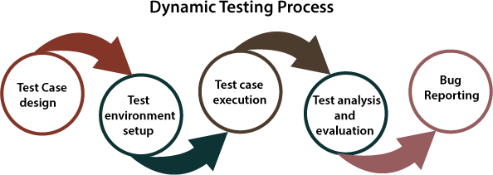

Step1: Test Case Design

In the first step of the dynamic testing process, the teams will design the test cases. Here, we are creating those test cases that depend on the requirements and scope of testing established before the start of the project.

In this step, we can originate the test conditions, obtain the test cases, extract the coverage Items, and identify those features that need to be tested.

Step2: Environment Setup

In the test environment phase, we will make sure that the testing environment should always be parallel to the production environment because the testing is implemented directly on the software product.

In this step, the dynamic testing process's main objective is to install the test environment, which helps us succeed in the test machines.

Step3: Test Execution

Once we successfully install the test environment, we will execute those test cases prepared in the primary stage of the dynamic testing process.

Step4: Analysis & Evaluation

After executing the test cases, we will analyse and evaluate the outcomes derived from the testing. And we will compare those outcomes with the expected results.

If expected and actual results are not the same according to executing, we will consider those test cases as fail, and log the Bug in the bug repository.

Step5: Bug Reporting

After analyzing the test cases, we will be reported and recorded any bugs or defects between the actual result and expected result to the concerned person. And the concerned person will make sure that the issue has been solved and delivering a quality product.

Example of Dynamic Testing
Let us take one sample example where we understand how dynamic testing will woks. So, for this, we will understand the login module of any application, such as www.
Twitter.com.

Suppose we want to create one new account with a secure password, so we need to follow some pre-defined rules in the password field.

And the password should have eight characters long, capital letters and at least one special character.

If we are testing this functionality, we would take all the input conditions to test this and then verify the output.

We can also put the non-working constraints, such as input a 4-character password, and validate if there is an error occurred or not.

Types of Dynamic testing

Dynamic testing divided into two different testing approach, which are as follows:

  - White-box testing
  - Black-box testing

Both the testing techniques will help us execute the dynamic testing process efficiently as they play an important role in verify the performance and quality of the software.

Let's understand them one by one in detail and also see the below diagram of it:
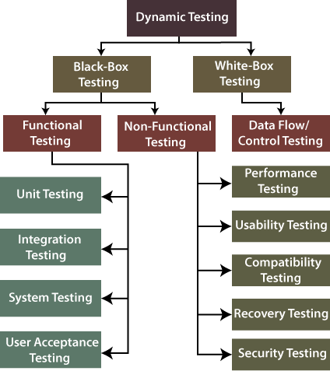

White-box testing

The word white box is used to describe the core perspective of the system. The developers will perform the white box testing, where they will test every line of the program's code.

When the developers perform the White-box testing and then send the software application to the testing team, the testing team will do the black box testing, validate the application as well as the requirements. The white-box testing is further divided into data flow/control testing.

Data flow Testing

The data flow testing is used to identify the program's test paths as per the settings of descriptions and uses of variables in the program. And it does not relate to data flow diagrams.

Black-box testing

The black-box testing is a testing technique where the test engineer selects a module and gives an input value to observe its functionality and analysis of whether the function is giving the expected output or not. If the function produced the correct output, then the particular function will be marked as pass.

To perform black-box testing, the test engineer should have specific knowledge about the software's requirement rather than programming knowledge of the software.

And then, they can develop the test cases to check the correctness of the software's functionality.

Black-box testing is further classified into two types, which are as follows:

  - Functional testing
  - Non-function testing

Functional testing

Functional testing is one of the most important parts of black-box testing. It mainly focuses on application specification rather than the actual code, and the test engineer will test the program rather than the system.

The functional testing is used to validate the software application's functionality, whether the function is working as per the requirement specification.

In functional testing, each module has been tested by giving the value, determining the output, and verifying the actual output with the expected value.

The functional testing is classified into four different type of testing, which are as follows:

  - Unit testing
  - Integration testing
  - System testing

  - User acceptance testing

Unit testing

  - The unit testing is the first level of functional testing to perform any testing on the software application.
  - We will perform the unit testing whenever the application is ready and given to the Test engineer. He/she will start checking every component of the module or application independently or one by one. And this process is known as components testing.
  - The primary objective to perform unit testing is to test the correctness of remote code and validate the unit components with their performance.

Integration testing

  - When we have successfully done the unit testing on the specific software, we will go for the integration testing. The integration testing will help us to combined individual units and tested as a group. And it is the second levelof functional testing.
  - When all the components or modules are working independently, we will check the data flow between the dependent modules, which is known as integration testing.
  - The developers and the test engineer perform the integration testing. And the main purpose of the integration is to identify the faults in the interaction between the integrated units.

System testing

  - System testing is used to check the end-to-end flow of an application or the software as a user.
  - System testing is also known as end-to-end testing as the testing environment is similar to the production environment.
  - In the third level (system testing) of functional testing, we go through all the necessary modules of an application and check if the end features or the end business works fine, and test the product as a whole system.

User acceptance testing

  - The user acceptance testing is performed to certify the system according to requirements. The customer or client does it before accepting the final product.

  - In other words, we can say that the UAT is done by the customer (domain expert) for their satisfaction and check whether the application is working according to given business scenarios and real-time scenarios.
  - It is the last level of functional testing, which is execute before releasing the software to the market or production environment where two or more end-users will involve.

Non- Functional testing

Another part of black-box testing is non-functional testing. It is used to test non-functional constraints like load test, reliability, performance, and software accountability.

The main objective of performing the non-functional testing is to test the software system's reading speed according to the non-functional parameters because these parameters are never tested before the functional testing.

Non-functional testing plays a vital role in customer satisfaction while testing the software or the application.

It reduces the risk of production and related costs of the software, and it provides a thorough knowledge of product behavior and used technologies.

Furthermore, the non-functional testing is divided into various parts, which can be performed at the test level.

  - Performance testing
  - Usability testing
  - Compatibility testing
  - Recovery testing
  - Security testing

Let's understand them in details one by one:

Performance Testing

  - The performance testing is the most importantly used type of non-functional
  - Once the software is stable and moved to the production, and it may be accessed by multiple users concurrently, we will do performance testing.
  - The performance testing is testing where we check the behavior of an application by applying some load.

  - As we know it is non-functional testing, which doesn't mean that we always use performance testing when the application is functionally stable; only then we go for performance testing.

Usability Testing

  - In usability testing, we will check the user-friendliness, efficiency, and accuracy of the software application.
  - If we are using usability testing, it ensures that the developed software is easy to test while using the system without facing any problem and makes end-user life easier.

Compatibility testing

  - The next type of non-functional testing is compatibility testing, which is used to check the functionality of an application on different software, hardware platforms, network, and browsers.
  - The compatibility testing is not performed for all the applications; we will use the compatibility testing only for those applications where we don't have control over the platform used by users.

Recovery testing

  - In recovery testing, we can verify how well a system can recover from hardware failures and crashes.
  - It reproduced the failure modes or essential producing failures in a controlled environment.
  - The recovery testing is performed to confirm that a system is fault-tolerant and can improve well from failures.

Security testing

  - The security testing is used to discover the weaknesses, risks, or threats in the software application and help us stop the nasty attack from outsiders and ensure our software applications' security.
  - The main purpose of security testing is to identify all the possible uncertainties and vulnerabilities of the application so that the software does not stop working.

Advantages and disadvantages of Dynamic Testing

From detecting and evaluating several bugs and errors in the software to verifying the software's performance, dynamic testing provides serval benefits to the users and the testing team.

However, we have various advantages of dynamic testing as well as some disadvantages. Therefore, below we listed some of the advantages and disadvantages of dynamic testing: Advantages
Following are the advantages of dynamic testing:

  - It validates the performance of the software application.
  - The usage of dynamic testing ensures the reliability and constancy of the software product.
  - It can automate with the help of tools that detect the problematic and complex bugs in the testing process, which cannot be covered through static Analysis.
  - It helps the testing team to identify the weak areas of the run-time environment.
  - The most important benefit of using dynamic testing over static testing is the relatively higher number of bugs can be found.
  - As compared to static testing, dynamic testing requires a smaller number of meetings at the planning level of testing.
  - It implements the software, end to end, and delivers Bug-free software.
  - It becomes an essential tool for identifying any security threats.
  - In dynamic testing, we can detect the problematic bugs which may have escaped the review processes.
  - It also identifying those bugs which cannot be noticed by static testing.
  - Dynamic testing can also find security threats, which ensure a better and secure application.

Disadvantages

Following are drawbacks of dynamic testing:

  - It is a time-consumingprocess as it implements the software application or code, which needs a massive resource.
  - The dynamic testing process is a bit costlieras it increases the budget of the software.

  - The dynamic testing needs more human resources to complete the task, which makes its implementation costlier.
  - Generally, dynamic testing is executed after the coding phase is completed, and therefore, the bugs are identified later in the life cycle.

Overview

In the dynamic testing section, we have learned the following topics:

  - After understood the dynamic testing above, we can easily say that the importance of dynamic testing is massive in the software testing life cycle (STLC).
  - Dynamic testing is used to perform the dynamic behavior of the code.
  - We have understood the process of dynamic Testing and the various types of dynamic testing.
  - In dynamic testing, we can directly implement the software tests to verify
the functional performance, behavior, reliability, and other significant features of the software.
  - We have understood the advantages and disadvantages of dynamic testing.

Statement Coverage Testing

Statement coverage is one of the widely used software testing. It comes under white box testing.

Statement coverage technique is used to design white box test cases. This technique involves execution of all statements of the source code at least once. It is used to calculate the total number of executed statements in the source code out of total statements present in the source code.

Statement coverage derives scenario of test cases under the white box testing process which is based upon the structure of the code.
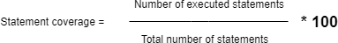

In white box testing, concentration of the tester is on the working of internal source code and flow chart or flow graph of the code.

Generally, in the internal source code, there is a wide variety of elements like operators, methods, arrays, looping, control statements, exception handlers, etc. Based on the input

given to the program, some code statements are executed and some may not be executed. The goal of statement coverage technique is to cover all the possible executing statements and path lines in the code.

Let's understand the process of calculating statement coverage by an example:

Here, we are taking source code to create two different scenarios according to input values to check the percentage of statement coverage for each scenario.

Source Code Structure:

  - Take input of two values like a=0 and b=1.
  - Find the sum of these two values.
  - If the sum is greater than 0, then print "This is the positive result."
  - If the sum is less than 0, then print "This is the negative result."

1. input (int a, int b) 2. {
- Function to print sum of these integer values (sum = a+b)
- If (sum>0) 5. {
- Print (This is positive result)
- } else
8. {
9. Print (This is negative result)
10. }
11. }

So, this is the basic structure of the program, and that is the task it is going to do.

Now, let's see the two different scenarios and calculation of the percentage of Statement Coverage for given source code.

Scenario 1:
If a = 5, b = 4

- print (int a, int b) {
- int sum = a+b;
- if (sum>0)
- print ("This is a positive result")
- else

- print ("This is negative result") 7. }
In scenario 1, we can see the value of sum will be 9 that is greater than 0 and as per the condition result will be "This is a positive result." The statements highlighted in yellow color are executed statements of this scenario.

To calculate statement coverage of the first scenario, take the total number of statements that is 7 and the number of used statements that is 5.

- Total number of statements = 7
- Number of executed statements = 5

1. Statement coverage = 5/7*100 2. = 500/7
3. = 71%
Likewise, in scenario 2, Scenario 2:
If A = -2, B = -7

- print (int a, int b) {
- int sum = a+b;
- if (sum>0)
- print ("This is a positive result")
- else
- print ("This is negative result") 7. }
In scenario 2, we can see the value of sum will be -9 that is less than 0 and as per the condition, result will be "This is a negative result." The statements highlighted in yellow color are executed statements of this scenario.

To calculate statement coverage of the first scenario, take the total number of statements that is 7 and the number of used statements that is 6.

Total number of statements = 7 Number of executed statements = 6

1. Statement coverage = 6/7*100 <br> 2. = 600/7
3. = 85%

But, we can see all the statements are covered in both scenario and we can consider that the overall statement coverage is 100%.

So, the statement coverage technique covers dead code, unused code, and branches.

Decision Coverage Testing

Decision coverage technique comes under white box testing which gives decision coverage to Boolean values. This technique reports true and false outcomes of Boolean expressions. Whenever there is a possibility of two or more outcomes from the statements like do while statement, if statement and case statement (Control flow statements), it is considered as decision point because there are two outcomes either true or false.

Decision coverage covers all possible outcomes of each and every Boolean condition of the code by using control flow graph or chart.

Generally, a decision point has two decision values one is true, and another is false that's why most of the times the total number of outcomes is two. The percent of decision coverage can be found by dividing the number of exercised outcome with the total number of outcomes and multiplied by 100.
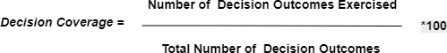

In this technique, it is tough to get 100% coverage because sometimes expressions get complicated. Due to this, there are several different methods to report decision coverage. All these methods cover the most important combinations and very much similar to decision coverage. The benefit of these methods is enhancement of the sensitivity of control flow.

We can find the number of decision coverage as follows. Let's understand it by an example.
Consider the code to apply on decision coverage technique:

1. Test (int a) 2. {
3. If(a>4)
4. a=a*3
5. Print (a) 6. }
Scenario 1:
Value of a is 7 (a=7)

1. Test (int a=7) 2. { if (a>4)
3. a=a*3
4. print (a) 5. }
The code highlighted in yellow is executed code. The outcome of this code is "True" if condition (a>4) is checked.

Control flow graph when the value of a is 7.

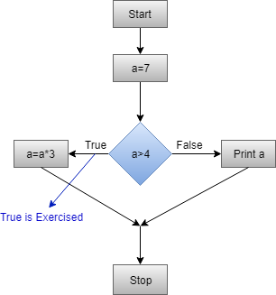

Calculation of Decision Coverage percent:

1. Decision Coverage = ½*100 (Only "True" is exercised) 2. =100/2
3. = 50
4. Decision Coverage is 50%

Scenario 2:
Value of a is 3 (a=3)

1. Test (int a=3) 2. { if (a>4)
3. a=a*3
4. print (a) 5. }
The code highlighted in yellow will be executed. The outcome of this code is ?False? if condition (a>4) is checked.

Control flow graph when the value of a is 3

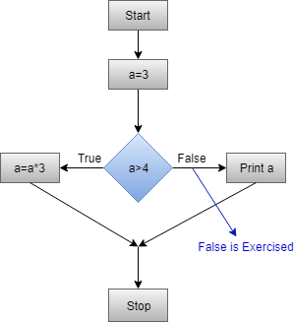

Calculation of Decision Coverage percent:

1. = ½*100 (Only "False" is exercised) <br> 2. =100/2
3. = 50
- Decision Coverage = 50%

Result table of Decision Coverage:

Test Case | Value of A | Output | Decision Coverage
1 | 3 | 3 | 50%
2 | 7 | 21 | 50%

What is Basis Path Testing?

Basis path testing, a structured testing or white box testing technique used for designing test cases intended to examine all possible paths of execution at least once. Creating and

executing tests for all possible paths results in 100% statement coverage and 100% branch coverage.

Example:
Function fn_delete_element (int value, int array_size, int array[])
{
- int i;
location = array_size + 1;

- for i = 1 to array_size 3 if ( array[i] == value ) 4 location = i;
end if; end for;

5 for i = location to array_size 6 array[i] = array[i+1];
end for;
7 array_size --;
}

Steps to Calculate the independent paths

Step 1 : Draw the Flow Graph of the Function/Program under consideration as shown below:
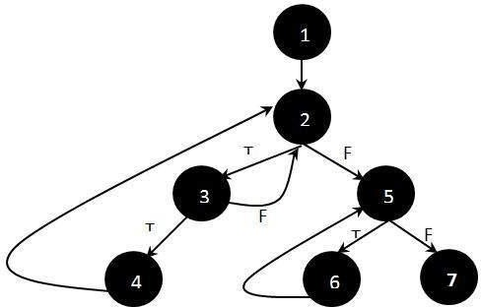

Step 2 : Determine the independent paths.
Path 1: 1 - 2 - 5 - 7

Path 2: 1 - 2 - 5 - 6 - 7
Path 3: 1 - 2 - 3 - 2 - 5 - 6 - 7
Path 4: 1 - 2 - 3 - 4 - 2 - 5 - 6 - 7

Control Flow Testing

Control flow testing is a testing technique that comes under white box testing. The aim of this technique is to determine the execution order of statements or instructions of the program through a control structure. The control structure of a program is used to develop a test case for the program. In this technique, a particular part of a large program is selected by the tester to set the testing path. It is mostly used in unit testing. Test cases represented by the control graph of the program.

Control Flow Graph is formed from the node, edge, decision node, junction node to specify all possible execution path.

Notations used for Control Flow Graph

  - Node
  - Edge
  - Decision Node
  - Junction node

Node

Nodes in the control flow graph are used to create a path of procedures. Basically, it represents the sequence of procedures which procedure is next to come so, the tester can determine the sequence of occurrence of procedures.

We can see below in example the first node represent the start procedure and the next procedure is to assign the value of n after assigning the value there is decision node to decide next node of procedure as per the value of n if it is 18 or more than 18 so Eligible procedure will execute otherwise if it is less than 18 Not Eligible procedure executes. The next node is the junction node, and the last node is stop node to stop the procedure.

Edge

Edge in control flow graph is used to link the direction of nodes.

We can see below in example all arrows are used to link the nodes in an appropriate direction.

Decision node

Decision node in the control flow graph is used to decide next node of procedure as per the value.

We can see below in example decision node decide next node of procedure as per the value of n if it is 18 or more than 18 so Eligible procedure will execute otherwise if it is less than 18, Not Eligible procedure executes.

Junction node

Junction node in control flow graph is the point where at least three links meet.

Example
1. public class VoteEligiblityAge{ 2.
- public static void main(String []args){
- int n=45; 5. if(n>=18) 6. {
- System.out.println("You are eligible for voting");
- } else
9. {
- System.out.println("You are not eligible for voting");
11. }
12. }
13. }

Diagram - control flow graph
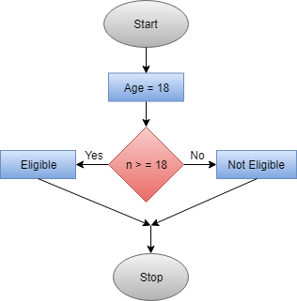

The above example shows eligibility criteria of age for voting where if age is 18 or more than 18 so print message "You are eligible for voting" if it is less than 18 then print "You are not eligible for voting."

Program for this scenario is written above, and the control flow graph is designed for the testing purpose.

In the control flow graph, start, age, eligible, not eligible and stop are the nodes, n>=18 is a decision node to decide which part (if or else) will execute as per the given value.
Connectivity of the eligible node and not eligible node is there on the stop node.

Test cases are designed through the flow graph of the programs to determine the execution path is correct or not. All nodes, junction, edges, and decision are the essential parts to design test cases.

Cyclomatic Complexity

Cyclomatic complexity is a software metric used to measure the complexity of a program. Thomas J. McCabe developed this metric in 1976.McCabe interprets a computer program as a set of a strongly connected directed graph. Nodes represent parts of the source code having no branches and arcs represent possible control flow transfers during program execution. The notion of program graph has been used for this measure, and it is used to measure and control the number of paths through a program. The complexity of a computer program can be correlated with the topological complexity of a graph.

How to Calculate Cyclomatic Complexity?

McCabe proposed the cyclomatic number, V (G) of graph theory as an indicator of software complexity. The cyclomatic number is equal to the number of linearly independent paths through a program in its graphs representation. For a program control graph G, cyclomatic number, V (G), is given as:

V (G) = E - N + 2 * P

E = The number of edges in graphs G N = The number of nodes in graphs G
P = The number of connected components in graph G.

Example:
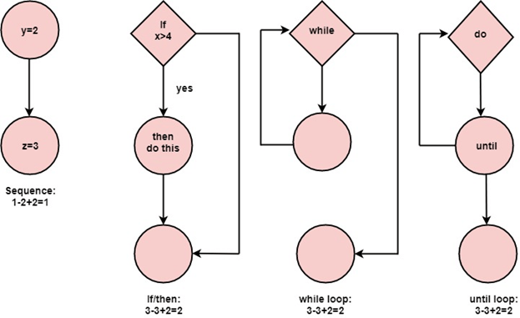

Properties of Cyclomatic complexity:

Following are the properties of Cyclomatic complexity:

  - V (G) is the maximum number of independent paths in the graph 2. V (G) >=1
- G will have one path if V (G) = 1
- Minimize complexity to 10

Mutation Testing

What is mutation testing?

Mutation testing is a white box method in software testing where we insert errors purposely into a program (under test) to verify whether the existing test case can detect the error or not. In this testing, the mutant of the program is created by making some modifications to the original program.

The primary objective of mutation testing is to check whether each mutant created an output, which means that it is different from the output of the original program. We will make slight modifications in the mutant program because if we change it on a massive scale than it will affect the overall plan.

When we detected the number of errors, it implies that either the program is correct or the test case is inefficient to identify the fault.

Mutation testing purposes is to evaluate the quality of the case that should be able to fail the mutant code hence this method is also known as Fault-based testing as it used to produce an error in the program and that why we can say that the mutation testing is performed to check the efficiency of the test cases.

What is mutation?

The mutation is a small modification in a program; these minor modifications are planned to typical low-level errors which are happened at the time of coding process.

Generally, we deliberate the mutation operators in the form of rules which match the data and also generate some efficient environment to produce the mutant.

Types of mutation testing

Mutation testing can be classified into three parts, which are as follows:

- Decision mutations
- value mutations
- Statement mutations

Let us understand them one by one:



Decision mutations

In this type of mutation testing, we will check the design errors. And here, we will do the modification in arithmetic and logical operator to detect the errors in the program.

Like if we do the following changes in arithmetic operators:

- plus(+)→ minus(-)

- asterisk(*)→ double asterisk(**)
- plus(+)→incremental operator(i++)

Like if we do the following changes in logical operators

- Exchange P > → P<, OR P>=

Now, let see one example for our better understanding:
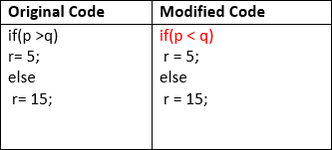

Value mutations

In this, the values will modify to identify the errors in the program, and generally, we will change the following:

- Small value à higher value
- Higher value àSmall value.

For Example:

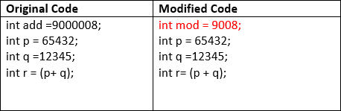

Statement Mutations

Statement mutations means that we can do the modifications into the statements by removing or replacing the line as we see in the below example:

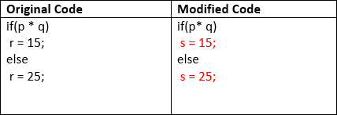

In the above case, we have replaced the statement r=15 by s=15, and r=25 by s=25. How to perform mutation testing
To perform mutation testing, we will follow the below process:

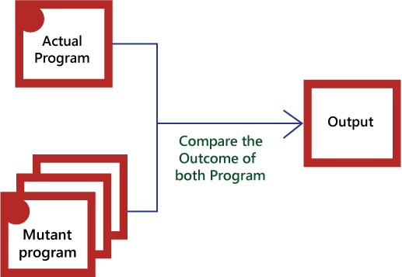

- In this, firstly, we will add the errors into the source code of the program by producing various versions, which are known mutants. Here every mutant having the one error, which leads the mutant kinds unsuccessful and also validates the efficiency of the test cases.
- After that, we will take the help of the test cases in the mutant program and the actual application will find the errors in the code.
- Once we identify the faults, we will match the output of the actual code and mutant code.
- After comparing the output of both actual and mutant programs, if the results are not matched, then the mutant is executed by the test cases. Therefore the test case

has to be sufficient for identifying the modification between the actual program and the mutant program.
- And if the actual program and the mutant program produced the exact result, then the mutant is saved. And those cases are more active test cases because it helps us to execute all the mutants.

Advantages and disadvantages of Mutation Testing

Advantages

The benefits of mutation testing are as follows:

- It is a right approach for error detection to the application programmer
- The mutation testing is an excellent method to achieve the extensive coverage of the source program.
- Mutation testing helps us to give the most established and dependable structure for the clients.
- This technique can identify all the errors in the program and also helps us to discover the doubts in the code.

Disadvantages

The drawbacks of mutant testing are as follows:

- This testing is a bit of time taking and costlier process because we have many mutant programs that need to be created.
- The mutation testing is not appropriate for Black-box testing as it includes the modification in the source code.
- Every mutation will have the same number of test cases as compare to the actual program. Therefore the significant number of the mutant program may need to be tested beside the real test suite.
- As it is a tedious process, so we can say that this testing requires the automation tools to test the application.

Black box testing

Black box testing is a technique of software testing which examines the functionality of software without peering into its internal structure or coding. The primary source of black box testing is a specification of requirements that is stated by the customer.

In this method, tester selects a function and gives input value to examine its functionality, and checks whether the function is giving expected output or not. If the function produces correct output, then it is passed in testing, otherwise failed. The test team reports the result to the development team and then tests the next function. After completing testing of all functions if there are severe problems, then it is given back to the development team for correction.
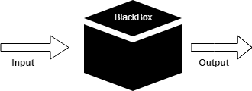

Generic steps of black box testing

- The black box test is based on the specification of requirements, so it is examined in the beginning.
- In the second step, the tester creates a positive test scenario and an adverse test scenario by selecting valid and invalid input values to check that the software is processing them correctly or incorrectly.
- In the third step, the tester develops various test cases such as decision table, all pairs test, equivalent division, error estimation, cause-effect graph, etc.
- The fourth phase includes the execution of all test cases.
- In the fifth step, the tester compares the expected output against the actual output.
- In the sixth and final step, if there is any flaw in the software, then it is cured and tested again.

Test procedure

The test procedure of black box testing is a kind of process in which the tester has specific knowledge about the software's work, and it develops test cases to check the accuracy of the software's functionality.

It does not require programming knowledge of the software. All test cases are designed by considering the input and output of a particular function.A tester knows about the definite output of a particular input, but not about how the result is arising. There are various techniques used in black box testing for testing like decision table technique, boundary value analysis technique, state transition, All-pair testing, cause-effect graph technique, equivalence partitioning technique, error guessing technique, use case technique and user story technique. All these techniques have been explained in detail within the tutorial.

Test cases

Test cases are created considering the specification of the requirements. These test cases are generally created from working descriptions of the software including requirements, design parameters, and other specifications. For the testing, the test designer selects both positive test scenario by taking valid input values and adverse test scenario by taking invalid input values to determine the correct output. Test cases are mainly designed for functional testing but can also be used for non-functional testing. Test cases are designed by the testing team, there is not any involvement of the development team of software.

Techniques Used in Black Box Testing

Decision Table Technique | Decision Table Technique is a systematic approach where various input combinations and their respective system behavior are captured in a tabular form. It is appropriate for the functions that have a logical relationship between two and more than two inputs.
Boundary Value Technique | Boundary Value Technique is used to test boundary values, boundary values are those that contain the upper and lower limit of a variable. It tests, while entering boundary value whether the software is producing correct output or not.
State Transition Technique | State Transition Technique is used to capture the behavior of the software application when different input values are given to the same function. This applies to those types of applications that provide the specific number of attempts to access the application.
All-pair Testing Technique | All-pair testing Technique is used to test all the possible discrete combinations of values. This combinational method is used for testing the application that uses checkbox input, radio button input, list box, text box, etc.
Cause-Effect Technique | Cause-Effect Technique underlines the relationship between a given result and all the factors affecting the result.It is based on a collection of requirements.
Equivalence Partitioning | Equivalence partitioning is a technique of software testing in which input data divided into partitions of valid and invalid values, and it

Technique | is mandatory that all partitions must exhibit the same behavior.
Error Guessing Technique | Error guessing is a technique in which there is no specific method for identifying the error. It is based on the experience of the test analyst, where the tester uses the experience to guess the problematic areas of the software.
Use Case Technique | Use case Technique used to identify the test cases from the beginning to the end of the system as per the usage of the system. By using this technique, the test team creates a test scenario that can exercise the entire software based on the functionality of each function from start to end.

Boundary Value Analysis

Boundary value analysis is one of the widely used case design technique for black box testing. It is used to test boundary values because the input values near the boundary have higher chances of error.

Whenever we do the testing by boundary value analysis, the tester focuses on, while entering boundary value whether the software is producing correct output or not.

Boundary values are those that contain the upper and lower limit of a variable. Assume that, age is a variable of any function, and its minimum value is 18 and the maximum value is 30, both 18 and 30 will be considered as boundary values.

The basic assumption of boundary value analysis is, the test cases that are created using boundary values are most likely to cause an error.

There is 18 and 30 are the boundary values that's why tester pays more attention to these values, but this doesn't mean that the middle values like 19, 20, 21, 27, 29 are ignored. Test cases are developed for each and every value of the range.

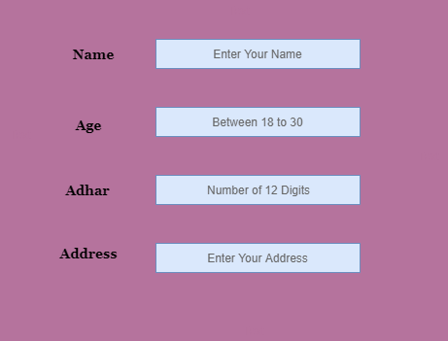

Testing of boundary values is done by making valid and invalid partitions. Invalid partitions are tested because testing of output in adverse condition is also essential.

Let's understand via practical:

Imagine, there is a function that accepts a number between 18 to 30, where 18 is the minimum and 30 is the maximum value of valid partition, the other values of this partition are 19, 20, 21, 22, 23, 24, 25, 26, 27, 28 and 29. The invalid partition consists of the numbers
which are less than 18 such as 12, 14, 15, 16 and 17, and more than 30 such as 31, 32, 34, 36 and 40. Tester develops test cases for both valid and invalid partitions to capture the behavior of the system on different input conditions.
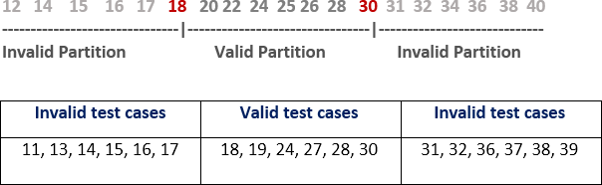

The software system will be passed in the test if it accepts a valid number and gives the desired output, if it is not, then it is unsuccessful. In another scenario, the software system should not accept invalid numbers, and if the entered number is invalid, then it should display error massage.

If the software which is under test, follows all the testing guidelines and specifications then it is sent to the releasing team otherwise to the development team to fix the defects.

Equivalence Partitioning Technique

Equivalence partitioning is a technique of software testing in which input data is divided into partitions of valid and invalid values, and it is mandatory that all partitions must exhibit the same behavior. If a condition of one partition is true, then the condition of another equal partition must also be true, and if a condition of one partition is false, then the condition of another equal partition must also be false. The principle of equivalence partitioning is, test cases should be designed to cover each partition at least once. Each value of every equal partition must exhibit the same behavior as other.

The equivalence partitions are derived from requirements and specifications of the software. The advantage of this approach is, it helps to reduce the time of testing due to a smaller number of test cases from infinite to finite. It is applicable at all levels of the testing process.

Examples of Equivalence Partitioning technique

Assume that there is a function of a software application that accepts a particular number of digits, not greater and less than that particular number. For example, an OTP number which contains only six digits, less or more than six digits will not be accepted, and the application will redirect the user to the error page.

1. 1. OTP Number = 6 digits
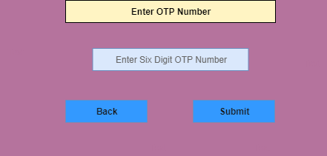
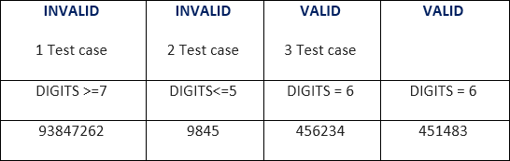

Let's see one more example.

A function of the software application accepts a 10 digit mobile number.

1. 2. Mobile number = 10 digits
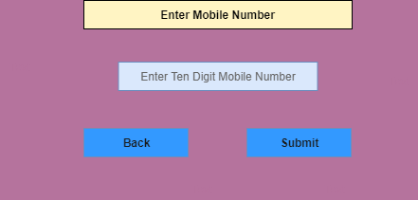
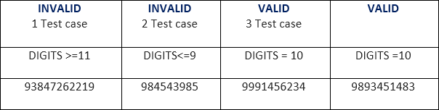

In both examples, we can see that there is a partition of two equally valid and invalid partitions, on applying valid value such as OTP of six digits in the first example and mobile number of 10 digits in the second example, both valid partitions behave same, i.e. redirected to the next page.

Another two partitions contain invalid values such as 5 or less than 5 and 7 or more than 7 digits in the first example and 9 or less than 9 and 11 or more than 11 digits in the second example, and on applying these invalid values, both invalid partitions behave same, i.e. redirected to the error page.

We can see in the example, there are only three test cases for each example and that is also the principal of equivalence partitioning which states that this method intended to reduce the number of test cases.

How we perform equivalence partitioning

We can perform equivalence partitioning in two ways which are as follows:

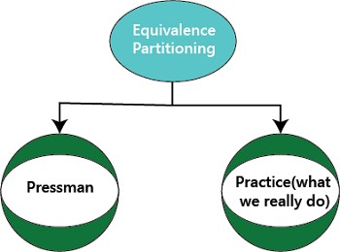

Let us see how pressman and general practice approaches are going to use in different conditions:

Condition1

If the requirement is a range of values, then derive the test case for one valid and two invalid inputs.

Here, the Range of values implies that whenever we want to identify the range values, we go for equivalence partitioning to achieve the minimum test coverage. And after that, we go for error guessing to achieve maximum test coverage.

According to pressman:

For example, the Amount of test field accepts a Range (100-400) of values:
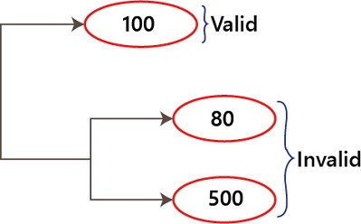

According to General Practice method:

Whenever the requirement is Range + criteria, then divide the Range into the internals and check for all these values.

For example:

In the below image, the pressman technique is enough to test for an age text field for one valid and two invalids. But, if we have the condition for insurance of ten years and above are required and multiple policies for various age groups in the age text field, then we need to use the practice method.
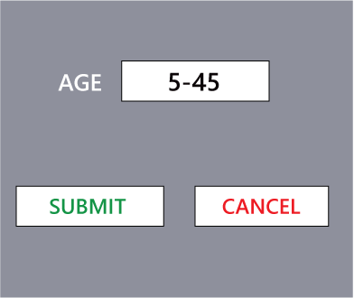

Condition2

If the requirement is a set of values, then derive the test case for one valid and two invalid inputs.

Here, Set of values implies that whenever we have to test a set of values, we go for one positive and two negative inputs, then we moved for error guessing, and we also need to verify that all the sets of values are as per the requirement.

Example 1

Based on the Pressman Method

If the Amount Transfer is (100000-700000) Then for, 1 lakh →Accept
And according to General Practice method The Range + Percentage given to 1 lakh - 7 lakh Like: 1lak - 3lak →5.60%
3lak - 6lak →3.66% 6lak - 7lak →Free

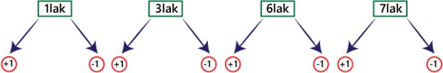

If we have things like loans, we should go for the general practice approach and separate the stuff into the intervals to achieve the minimum test coverage.

Example 2

if we are doing online shopping, mobile phone product, and the different Product ID -

1,4,7,9
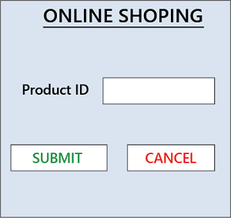

Here, 1 → phone covers 4 → earphones 7 → charger 9 → Screen guard

And if we give the product id as 4, it will be accepted, and it is one valid value, and if we provide the product id as 5 and phone cover, it will not be accepted as per the requirement, and these are the two invalid values.
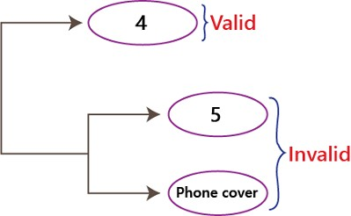

Condition 3

If the requirement id Boolean (true/false), then derive the test case for both true/false values.

The Boolean value can be true and false for the radio button, checkboxes.

For example
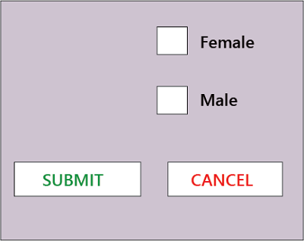

Serial no | Description | Input | Expected | Note
1 | Select valid | NA | True | ---
2 | Select invalid | NA | False | Values can be change based according to the requirement.
3 | Do not select | NA | Do not select anything, error message should be displayed | We cannot go for next question

4 | Select both | NA | We can select any radio button | Only one radio button can be selected at a time.

Note:

In Practice method, we will follow the below process:

Here, we are testing the application by deriving the below inputs values:
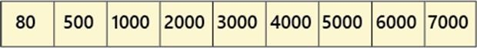

Let us see one program for our better understanding.

1. If( amount < 500 or > 7000)
2. {
3. Error Message 4. }
5. if( amount is between 500 & 3000) 6. {
7. deduct 2% 8. }
9. if (amount > 3000)
10. {
- deduct 3%
12. }

When the pressman technique is used, the first two conditions are tested, but if we use the practice method, all three conditions are covered.

We don't need to use the practice approach for all applications. Sometime we will use the pressman method also.

But, if the application has much precision, then we go for the practice method. If we want to use the practice method, it should follow the below aspects:
- It should be product-specific
- It should be case-specific

- The number of divisions depends on the precision( 2% and 3 % deduction) Advantages and disadvantages of Equivalence Partitioning technique
Following are pros and cons of equivalence partitioning technique:

Advantages | Disadvantages
It is process-oriented | All necessary inputs may not cover.
We can achieve the Minimum test coverage | This technique will not consider the condition for boundary value analysis.
It helps to decrease the general test execution time and also reduce the set of test data. | The test engineer might assume that the output for all data set is right, which leads to the problem during the testing process.

Cause and Effect Graph in Black box Testing

Cause-effect graph comes under the black box testing technique which underlines the relationship between a given result and all the factors affecting the result. It is used to write dynamic test cases.

The dynamic test cases are used when code works dynamically based on user input. For example, while using email account, on entering valid email, the system accepts it but, when you enter invalid email, it throws an error message. In this technique, the input conditions are assigned with causes and the result of these input conditions with effects.

Cause-Effect graph technique is based on a collection of requirements and used to determine minimum possible test cases which can cover a maximum test area of the software.

The main advantage of cause-effect graph testing is, it reduces the time of test execution and cost.

This technique aims to reduce the number of test cases but still covers all necessary test cases with maximum coverage to achieve the desired application quality.

Cause-Effect graph technique converts the requirements specification into a logical relationship between the input and output conditions by using logical operators like AND, OR and NOT.

Notations used in the Cause-Effect Graph

AND - E1 is an effect and C1 and C2 are the causes. If both C1 and C2 are true, then effect E1 will be true.
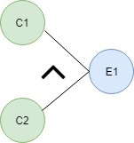

OR - If any cause from C1 and C2 is true, then effect E1 will be true.
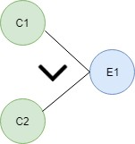

NOT - If cause C1 is false, then effect E1 will be true.
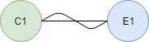

Mutually Exclusive - When only one cause is true.
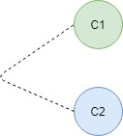

Let's try to understand this technique with some examples:

Situation:

The character in column 1 should be either A or B and in the column 2 should be a digit. If both columns contain appropriate values then update is made. If the input of column 1 is incorrect, i.e. neither A nor B, then message X will be displayed. If the input in column 2 is incorrect, i.e. input is not a digit, then message Y will be displayed.

- A file must be updated, if the character in the first column is either "A" or "B" and in the second column it should be a digit.
- If the value in the first column is incorrect (the character is neither A nor B) then massage X will be displayed.
- If the value in the second column is incorrect (the character is not a digit) then massage Y will be displayed.
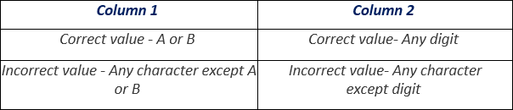

Now, we are going to make a Cause-Effect graph for the above situation:

Causes are:

- C1 - Character in column 1 is A
- C2 - Character in column 1 is B
- C3 - Character in column 2 is digit!

Effects:

- E1 - Update made (C1 OR C2) AND C3
- E2 - Displays Massage X (NOT C1 AND NOT C2)
- E3 - Displays Massage Y (NOT C3) Where AND, OR, NOT are the logical gates.

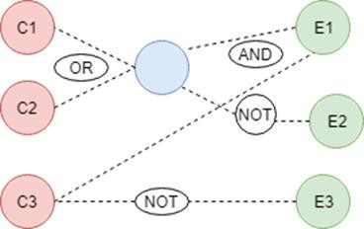

Effect E1- Update made- The logic for the existence of effect E1 is "(C1 OR C2) AND C3". For C1 OR C2, any one from C1 and C2 should be true. For logic AND C3 (Character in column 2 should be a digit), C3 must be true. In other words, for the existence of effect E1 (Update made) any one from C1 and C2 but the C3 must be true. We can see in graph cause C1 and C2 are connected through OR logic and effect E1 is connected with AND logic.

Effect E2 - Displays Massage X - The logic for the existence of effect E2 is "NOT C1 AND NOT C2" that means both C1 (Character in column 1 should be A) and C2 (Character in column 1 should be B) should be false. In other words, for the existence of effect E2 the character in column 1 should not be either A or B. We can see in the graph, C1 OR C2 is connected through NOT logic with effect E2.

Effect E3 - Displays Massage Y- The logic for the existence of effect E3 is "NOT C3" that means cause C3 (Character in column 2 is a digit) should be false. In other words, for the existence of effect E3, the character in column 2 should not be a digit. We can see in the graph, C3 is connected through NOT logic with effect E3.

So, it is the cause-effect graph for the given situation. A tester needs to convert causes and effects into logical statements and then design cause-effect graph. If function gives output (effect) according to the input (cause) so, it is considered as defect free, and if not doing so, then it is sent to the development team for the correction.

Conclusion

Summary of the steps:

- Draw the circles for effects and Causes.
- Start from effect and then pick up what is the cause of this effect.
- Draw mutually exclusive causes (exclusive causes which are directly connected via one effect and one cause) at last.
- Use logic gates to draw dynamic test cases.

Decision table technique in Black box testing

Decision table technique is one of the widely used case design techniques for black box testing. This is a systematic approach where various input combinations and their respective system behavior are captured in a tabular form.

That's why it is also known as a cause-effect table. This technique is used to pick the test cases in a systematic manner; it saves the testing time and gives good coverage to the testing area of the software application.

Decision table technique is appropriate for the functions that have a logical relationship between two and more than two inputs.

This technique is related to the correct combination of inputs and determines the result of various combinations of input. To design the test cases by decision table technique, we need to consider conditions as input and actions as output.

Let's understand it by an example:

Most of us use an email account, and when you want to use an email account, for this you need to enter the email and its associated password.

If both email and password are correctly matched, the user will be directed to the email account's homepage; otherwise, it will come back to the login page with an error message specified with "Incorrect Email" or "Incorrect Password."

Now, let's see how a decision table is created for the login function in which we can log in by using email and password. Both the email and the password are the conditions, and the expected result is action.
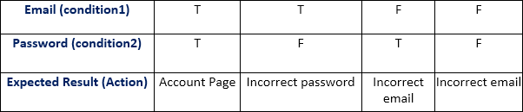

In the table, there are four conditions or test cases to test the login function. In the first condition if both email and password are correct, then the user should be directed to account's Homepage.

In the second condition if the email is correct, but the password is incorrect then the function should display Incorrect Password. In the third condition if the email is incorrect, but the password is correct, then it should display Incorrect Email.

Now, in fourth and last condition both email and password are incorrect then the function should display Incorrect Email.

In this example, all possible conditions or test cases have been included, and in the same way, the testing team also includes all possible test cases so that upcoming bugs can be cured at testing level.

In order to find the number of all possible conditions, tester uses 2^{n} formula where n denotes the number of inputs; in the example there is the number of inputs is 2 (one is true and second is false).

Number of possible conditions = 2^ Number of Values of the second condition Number of possible conditions =2^2 = 4

While using the decision table technique, a tester determines the expected output, if the function produces expected output, then it is passed in testing, and if not then it is failed. Failed software is sent back to the development team to fix the defect.

